Effective Evangelism
James Plamondon, Technical Evangelist

Evangelism Is War
Our mission is to establish Microsoft's platforms as the de facto standards throughout the computer industry. Our enemies are the vendors of platforms that compete with ours: Netscape, Sun, IBM, Oracle, Lotus, etc. The field of battle is the software industry. Success is measured in shipping applications. Every line of code that is written to our standards is a small victory; every line of code that is written to any other standard, is a small defeat. Total victory, for DRG, is the universal adoption of our standards by developers, as this is an important step towards total victory for Microsoft itself: "A computer on every desk and in every home, running Microsoft software "
Our weapons are psychological, economic, and political — not military. No one is forced to adopt our standards at the barrel of a gun. We can only convince, not compel. Those who adopt our standards do so as a rational decision to serve their own ends, whatever those may be. It is our job to ensure that those choosing an operating system are presented with an overwhelming abundance of evidence and reasoned argument in favor of our standards—so overwhelming that the choice of our standards seems obvious, or (ideally) that the developer is not even aware that a decision was faced, and a choice made.
We do this by understanding the barriers that might otherwise prevent the developer from adopting our standards, and removing them; by understanding the inducements that might facilitate the developer's adoption of our standards, and providing them; by understanding the arguments of our competition, and countering them.

Our Mission
The Charter of Microsoft's Developer Relations Group is clear:
Drive the success of Microsoft’s platforms by creating a critical mass of third-party software applications and business solutions.
This mission statement contains both the goal which we are striving to achieve (the success of Microsoft's platforms) as well as the means by which we are to achieve it (by creating a critical mass of third-party applications and business solutions). Let us examine it carefully.

Platforms
What is a platform? A platform is any software service which an ISV's code assumes is present in order for it to function properly. For example, Windows is a platform, because ISVs can write code that assumes the presence of the Windows DLLs, and which will not function properly in their absence.
What are Microsoft's platforms? Once, the answer was simple: Windows (and before that, DOS). Now, Microsoft has many platforms, and the answer is more complicated. Windows is still one of Microsoft's platforms. New platforms include Microsoft Office, Microsoft Back Office, Microsoft Exchange, The Microsoft Network, Microsoft Internet Explorer, DevOffice, and ActiveX. For each of these, ISVs can (or will be able to) write code that assumes the platform's presence.
Turning a product into a platform perpetuates and broadens the success of the product. This is because writing code to support even one platform is hard; writing code to support multiple, alternative platforms is exponentially more difficult. This leads developers to choose between alternative platforms, and (ideally) choose one over all others. This choice, once made, is not easily changed; code written to one platform is only re-written to another with difficulty. In effect, once a developer chooses a platform, the developer is "locked in" to that platform.

Critical Mass
"Critical mass" is a term borrowed from nuclear physics, in which it means "a sufficient mass of fissionable material to sustain a chain reaction," in which a chain reaction is defined to be "a self-sustaining nuclear reaction yielding energy that causes further reactions of the same kind."
"Self-sustaining" is the key phrase in this definition. Once started, the nuclear reaction naturally re-invests its energy in perpetuating and growing the reaction. Once the point of criticality is reached, no additional external energy or intervention is required to maintain the reaction.
So it is with evangelism. Once a platform has reached a certain degree of support in the industry, it becomes self-perpetuating (for reasons discussed below). Once this "critical mass" of support for a given platform has been achieved, new applications will tend to support it too, even in the absence of further evangelism.
Note that were are concerned with the "mass" of support by. Both the number and the importance of applications supporting a platform contribute to the overall mass of the platform's support.
Mass in motion gives momentum, which can be defined as the amount of effort required over a given time to stop a body in motion. A sufficient mass of applications delivering support for a platform over a sufficiently short time, gives the platform sufficient momentum that it is, for all practical purposes, unstoppable.
Current economic theory suggests that the emergence of a dominant standard from a number of competing alternatives, is the result of "random events." It is our job to ensure that there's nothing random about it: we create the platform momentum that ensures Microsoft's victory.

Third-Party Applications and Business Solutions
Platforms, by themselves, are of little or no value to end users. Their value is derived from the applications and business solutions which take advantage of the platforms' services in order to deliver real value to the customer. If we wish our platforms to be successful, we must ensure that our platforms are used by the applications and business solutions that customers want.
Third-party applications and business solutions are the measurement of the success of evangelism. The greater the mass of shipping applications that supports our platforms, the more successful we have been.
The art of evangelism is concerned with increasing the mass of applications and business solutions, that support our platforms, to the point of criticality.

Our Enemies
Some have claimed that Microsoft has a monopoly on the market for operating systems designed for personal computers. This is patently untrue. IBM's OS/2, Apple's MacOS, Novell's Unix and NetWare, Taligent's CommonPoint, Netscape's Navigator, and other operating systems (or embryonic operating systems), all compete with Windows in the struggle for applications and business solutions. This is true for our other platforms as well (Exchange/Notes, OLE/OpenDoc, Office/SmartSuite, etc.).
Nor is this a static list. The computer industry is very dynamic; we in evangelism must be even more dynamic - constantly searching for new allies, enemies, and strategies.
It is beyond the scope of this paper to expound on the strengths and weaknesses of each of our competitors. There are many other sources of such information. Use them!

The Field of Battle
The software industry is the field on which evangelists do battle. The industry has its own trade press, book publishers, developer SIGs, conferences, tradeshows, training organizations, retailers, wholesalers, and distributors. It has its own culture. Understanding the terrain of the industry is essential to effective evangelism.
It is not effective to publish an article about Mac OLE in a Unix magazine, or to give a talk on Win32's memory-mapped file I/O at a conference attended by executives. To be effective, the right tools and messages must be delivered to the right place, at the right time.
Some ISVs and their applications are more important to the success of a platform than others. They are the high ground of the battlefield. Gaming the support of a major ISV is like taking a hill; from there, you command the battlefield below. The same can be said for the trade magazines, conferences, developer SIGs, etc.. You cannot control the field of battle if the high ground is in the hands of the enemy.

The Measure of Success
The success of evangelism is measured in the mass of shipping applications that support Microsoft's platforms. Those applications that support a given platform, move it closer to critical mass, and thus count as successes; those that support a competing platform, move it away from critical mass, and thus count as defeats.
Microsoft has many platforms, and what appears to be a victory for one Microsoft platform may appear to be a defeat for another. If OLE is successful on the Macintosh (making Macintosh applications more powerful), is that a victory for OLE, or a defeat for Windows? If Windows API is successful on Unix (making Unix applications less expensive to develop), is that a victory for the Win32 API, or a defeat for Windows NT?
Diversionary attacks, holding actions, and retreats may each seem contrary to the achievement of the overall objective when considered solely in their own terms, but taken in light of the overall conflict, may contribute to overall success. In the Chinese Civil War that followed World War II, Mao Tse Tung's Army ran away from every battle, until they won the war. They knew that overall victory, not local victory, was the objective.
Thus it is imperative to measure each action in accordance with its contribution to overall, not just local, victory.

Victory
"A computer on every desk and in every home, running Microsoft software." This is the mission statement of Microsoft itself; it is the definition of the conditions under which Microsoft itself can declare overall victory.

Definition of Evangelism at Microsoft
Evangelism is the art and science of getting developers to ship products that support Microsoft's platforms."

Effective Evangelism (Powerpoint Presentation)
James Plamondon, Technical Evangelist Microsoft Developer Relations Group

Mission Statement
"Drive the success of Microsoft's platforms by creating a critical mass of third-party software applications and business solutions."

"We're Just Here to Help Developers "

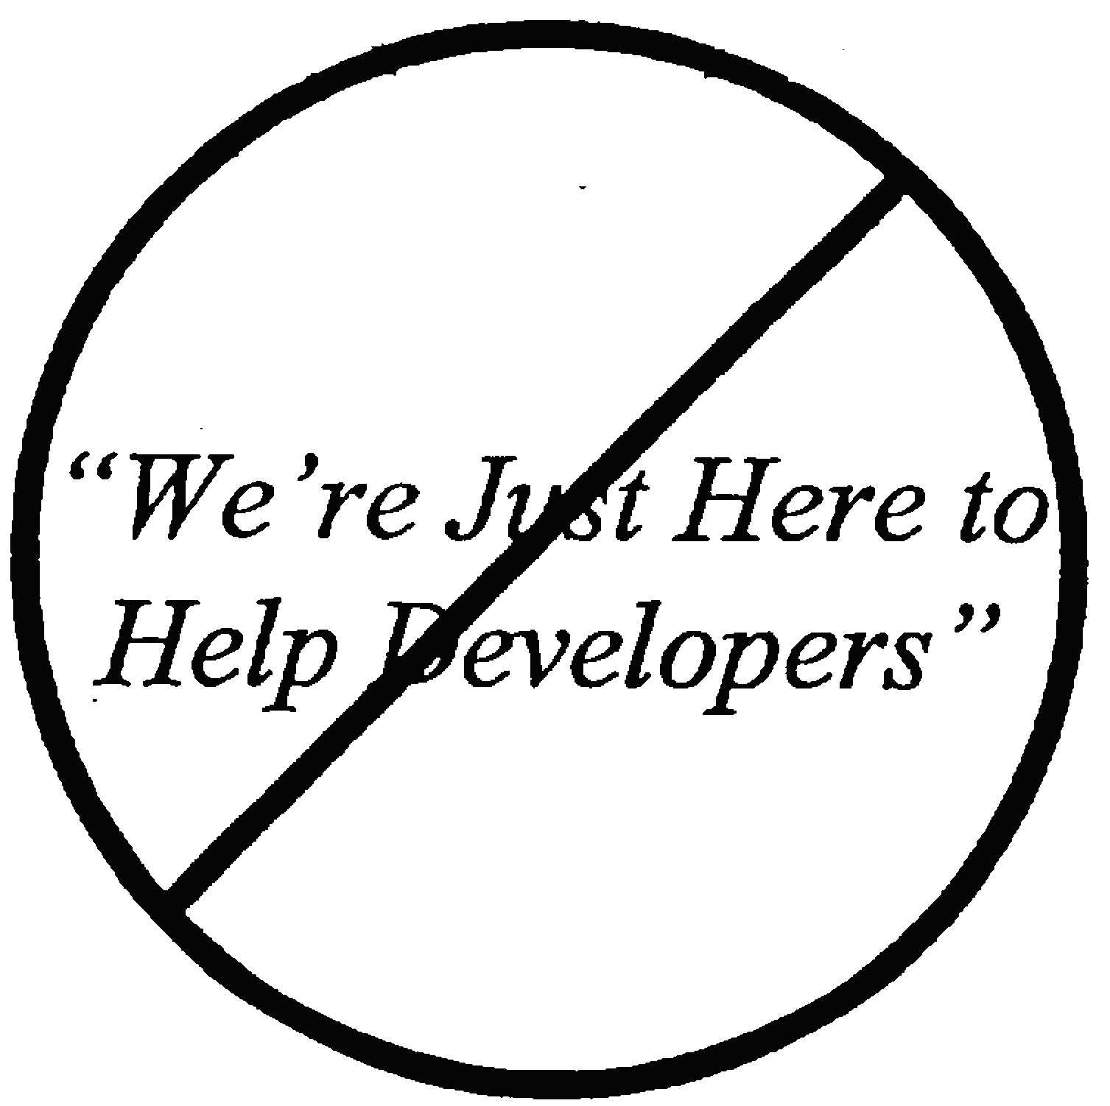

We Are Here to Help MICROSOFT

Evangelism is WAR!
Mission
- Establish Microsoft's platforms as de facto standards
Enemies
- Other platform vendors
Battlefield
- ISV Mindshare
Progress
- Shipping ISV applications

Role of ISVs
ISVs are just pawns in the struggle
- But have you ever tried to win a chess game without any pawns?
We need the support of ISVs to win
We must earn the support of ISVs, by
- Shipping technologies worthy of support
- Helping ISVs implement and market their support for our technologies
We work hard to help our ISVs succeed!

So, We 're Just Here to Help Developers, Right?

We're Here to Help Microsoft
Microsoft pays our wages
Microsoft provides our stock options
Microsoft pays our expenses
We're Here to Help Microsoft
- By helping those developers...
- ...That can best help Microsoft'...
- ...Achieve Microsoft 's objectives.
Did anyone miss the point, here?

So, How Do We Accomplish This Mission?

Mission Statement
"Drive the success of Microsoft's platforms by creating a critical mass of
third-party software applications and business solutions."

Mission Statement
"Drive the success of Microsoft's platforms by creating a critical mass of
third-party software applications and business solutions."

Mission Statement
"Drive the success of Microsoft's platforms by creating a critical mass of
third-party software applications and business solutions."

What is a "Platform"?
Software service required by an ISV's app
Windows, OS/2, Mac OS
OLE, OpenDoc, CORBA, [D]SOM
Exchange, Notes
Office, SmartSuite, PerfectOffice
BackOffice, Oracle, AS/400 apps
Java, Navigator, the Web.. ActiveX

Platform Example: Win32
Win32 on Windows
- Windows NT, Win32s, Windows 95
Win32 API on Unix
- Sun, WABI
- Bristol, MainSoft
Win32 API on Mac
- Visual C++ for Macintosh
Result: Win32 is the Universal API
- We Win!

Mission Statement
"Drive the success of Microsoft's platforms by creating a critical mass of
third-party software applications and business solutions."

Critical Mass
"A sufficient mass of fissionable material to sustain a chain reaction"
Chain reaction
- "A self-sustaining nuclear reaction yielding energy that causes further reactions of the same kind."
Result
- Physics: Nuclear explosion
- Evangelism: De facto standard

Nukes 'R Us
We create chain reactions
Fissionable Material: Shipping Apps
- Mindshare
- Market Share
Other Components
- Timers, plastique, casing, delivery systems
- Sample code, white papers, presentations, books, articles, meetings, press releases
Blow the competition away

Self-Sustaining
Platform is
- Expected by reviewers
- Supported by tools, books, consultants, trainers
"... yielding energy that causes further reactions of the same kind."
- It's evangelizing itself
- So Microsoft can stop evangelizing it
Victory!

Mission Statement
"Drive the success of Microsoft's platforms by creating a critical mass of
third-party software applications and business solutions."

Third-Parties
Not Microsoft or its competitors
- First parties
Not our customers
- Second parties
Other software vendors
- Third parties

Why Not Do It All Ourselves?
Because we can't
- There's just too much to be done
Because they won't let us
- Lawyers 'R Us
Because third-parties are more efficient
- In their respective markets

Enlightened Self-Interest
We help ISVs to help ourselves
But we really do help them
We fight for our ISV's
- APIs, hooks, tool support
- Design Reviews
- Strategies, timelines, etc.
- ...because we need their support for our own ends

Too Many to Help
Can't help 'em all
We help those who can help us.
If they can't or won't help us
- Screw'em!
- Help their competitors instead

Summary
We're here to help Microsoft...
...By helping those ISVs...
...That can help Microsoft...
...Achieve its objectives.

Strategy
Or, How to Kick Ass Without Breaking a Sweat

Strategy
To win one hundred battles is not perfection; to subdue the enemy without fighting is perfection.
Sun-Tzu: The Art Of War, written in China by Sun Wu in roughly 490 B.C.

Strategy of Sun Tzu
"Thus, the best military strategy is to attack the enemy's plans.
Next best is to disrupt his alliances.
The next best is to crush his army.
The worst policy is to attack his fortified cities. Attack cities only when there is no alternative."

Attack the Enemy's Plans
Do not attack directly
- No debates, no white papers, no lawsuits
Do the unexpected; attack his assumptions

Example: Win32 API on Unix
Sun's plan
- Implement Win32 on Unix (WABI)
- Unix would run Windows software
Assumption: MS would try to block WABI through legal action
Microsoft's response
- Put Win32 on Unix ourselves
- Through Bristol, Mainsoft, Locus, etc.
- They pay us a fee and a royalty
- Don't sue; compete!

Crush The Enemy's Army
Head-to-head evangelism
- White paper wars
- Panel debates
- Technology duels
Both sides lose
- Credibility
- Opportunity cost
Avoid this strategy!

Example: OLE vs. OpenDoc
The Old Strategy
Direct competition on tech details
Press, pundits LOVE this!
- Conflict!
- Underdog!
ISVs are confused, so they do nothing
- "I'll wait to see who wins"
- OpenDoc's FUD worked
Complete disaster
- Delayed the widespread adoption of OLE

Disrupt The Enemy's Alliances
Alliances are weak
Circumstances change over time
- Technology, personnel, regulation, mergers
Once-mutual interests, diverge
- AppWare Foundation
Each ally schemes for advantage
- And to minimize its costs

Example: OLE vs. OpenDoc
The New Strategy
Allies
- Apple, Novell, IBM
Strategy
- Disrupt the alliance
Tactics
- Reposition OpenDoc as an OLE dev. tool
- Put OLE in the Enterprise
- pits Apple against IBM & Novell
- Help Claris & WP support OLE in Win95
- pits part of an ally against itself

Attack The Enemy's Fortified Cities
Big ISVs that compete with Microsoft
- Lotus, Novell, Oracle,...
They hate us
- and there's nothing we can do about it.
Don't throw yourself against their walls
Help their competitors instead
- Let them attack the cities for us
- They'll be grateful for our help (for a little while...)

Victory Conditions
You win when the enemy quits
- and not before
What will cause the enemy to quit?
- Lack of support
- Public humiliation
- Low return on Investment
- Nothing
Don't start fighting, until you can identify when you've won

All Is Not Fair
We are under close scrutiny
- Any unethical acts WILL BE uncovered
Besides - we're the good guys!
Simple rule to live by: Never Lie
- Tell the truth, and nothing but the truth
- Be selective in which truths you emphasize
- Let the competition fill in the gaps

Next Time
Power Evangelism
- Definition of Power in Evangelism. Resource exchange. Gaining power. Using power. Getting things done. Leverage. Influence. Mind Control. Tactics.

It is arguable that it is this unstoppable momentum, not just sufficient mass, that is our objective; however, since unstoppable momentum is an inevitable consequence of attaining critical mass, the distinction is moot
"Increasing Returns" theory, promulgated by Brian Arthur of Stanford.
Historically, DRG has not evangelized the use of our platforms by Microsoft's own applications and business solutions. It is assumed that they are fully supporting our platforms. But as our technologies have become more numerous and complex, the need for internal evangelism has increased. Such internal evangelism can be highly leveraged, because our applications play an important role in setting standards in the industry. When the internal evangelism will clearly further DRG's ends, do it; but remember that at present, internal evangelism is not itself in DRG's charter — so it's a means to an end, not an end in itself.

